Contact:
Christie Kozak | Leary PR | christie@learypr.com | 978-502-5747

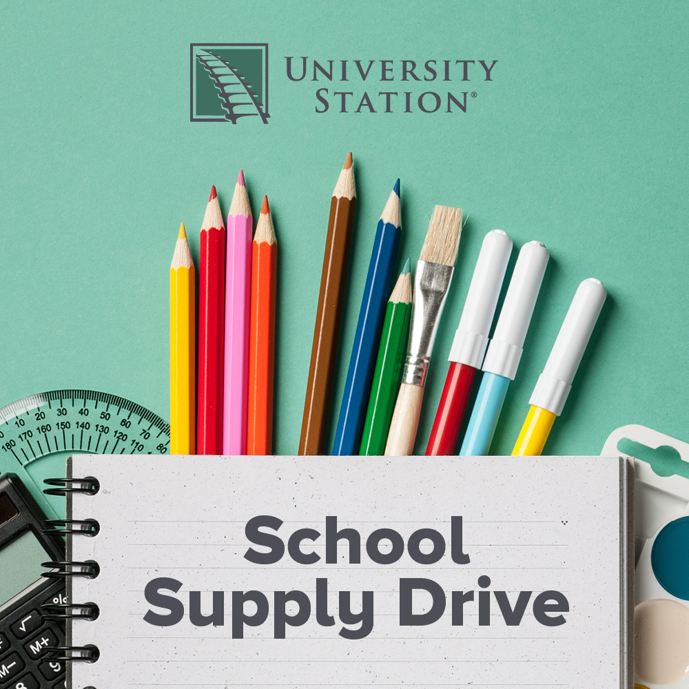

University Station Hosts School Supply Drive for
School on Wheels of Massachusetts

Donations accepted through August 25, 2024

WESTWOOD, MA (July 2024) – University Station in Westwood is hosting a School Supply Drive for School on Wheels of Massachusetts now through August 25, 2024. Donations can be dropped off in the marked donation bin located at Five Below.

Suggested donations include new, unused backpacks, pencils & pencil sharpeners, pencil pouches, erasers, glue sticks, highlighters, plastic rulers, washable markers, composition notebooks and more. These donations will directly impact the work of School on Wheels of Massachusetts, whose mission is to support the academic, social, and emotional growth of students impacted by homelessness. Online donations to purchase school supplies can be made at SOWMA.org.

“For the children School on Wheels of Massachusetts serves, the backpack isn't just a school accessory; it is an important part of their identity. It becomes a locker for their school supplies and personal belongings, a reliable companion, and a safety net, helping them fit in with their peers as they walk into school on the first day. The tools inside the backpack, provided by SOWMA, ensure they are prepared for the classroom without worrying about what they lack,” explains Barbara Fox, Community Outreach Director for School on Wheels.

“University Station is pleased to continue to support School on Wheels of Massachusetts to help children receive the supplies they need to start the school year,” says Rebekah Macchia, Marketing Director of University Station. For more information, visit ShopUniversityStation.com.

About School on Wheels of Massachusetts
School on Wheels of Massachusetts (SOWMA) was founded in 2004 to bring one-on-one academic support to children struggling to stay on track and in school while experiencing homelessness. Since the start of the 2020/2021 academic year, SOWMA has distributed more than 6,000 new customized, grade-level backpacks to children and at-risk youth living in 38 Massachusetts communities. Trained volunteers provide one-on-one tutoring to 280 students at 18 program site locations from Boston to the South Coast. The Bridge Mentoring Program provides 57 high school and college-age students with a volunteer mentor, who shepherds students through high school and onto post-secondary plans, including college, vocational training, and jobs.
For more information, visit SOWMA.org.

University Station
University Station is a vibrant, mixed-used development in Westwood, Massachusetts combining unique retail, restaurant, residential and office uses. Located on University Avenue at Exit 13 on Route 128/I-95, University Station is adjacent to the Route 128 MBTA Commuter Rail/Amtrak Station. Anchored by Target, Wegmans and Nordstrom Rack, University Station features an exciting mix of restaurants and stores including Del Frisco’s Grille, Anthony’s Coal Fired Pizza, Not Your Average Joe’s, Smashburger, Homesense, Michaels, Marshalls/HomeGoods, PetSmart, Ulta Beauty, Five Below, J.Crew Factory, Bath & Body Works, and Ann Taylor Factory. Courtyard by Marriott®, Life Time Athletic, Brigham & Women’s Health Care Center, Gables Residential (featuring 350 luxury apartments) and Bridges by Epoch (a memory care facility) are also at University Station. For more information, visit ShopUniversityStation.com.

# # #

