**Contact**:

Christie Kozak | Leary PR | [christie@learypr.com](mailto:christie@learypr.com) | 978-502-5747

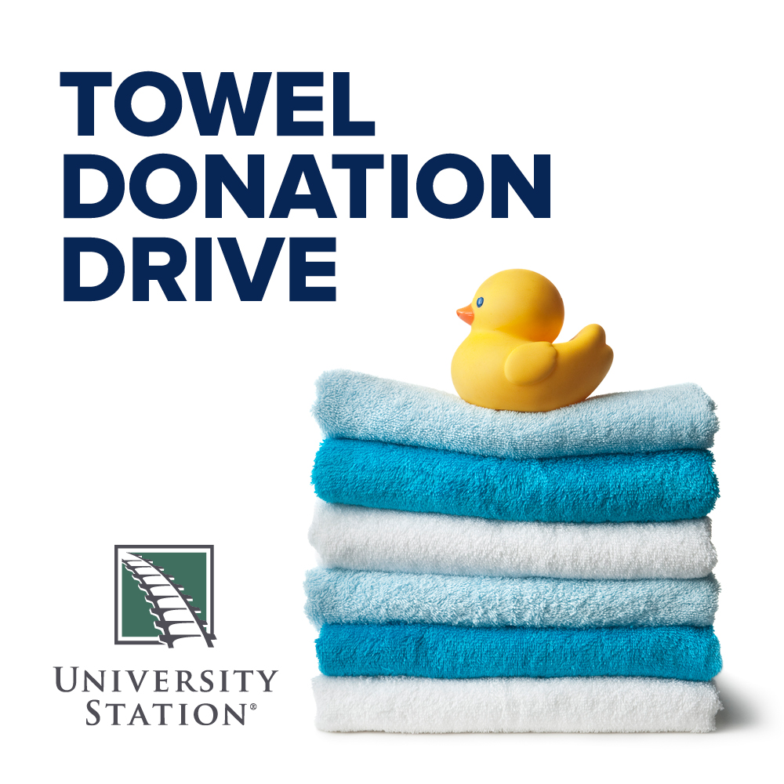

**University Station Hosts Towel Donation Drive**

**Benefitting Local Non-Profit Welcome Home**

WESTWOOD, MASSACHUSETTS (April 2024) – University Station in Westwood ([ShopUniversityStation.com](http://www.ShopUniversityStation.com))

is hosting a towel donation drive to benefit Welcome Home, a local home goods pantry based in Newton, MA. Welcome Home provides families experiencing hardship with the basic household items they need to live with dignity. Now through April 30, 2024, donations of new towels can be dropped off in the marked bin at Five Below. To make a monetary donation, visit [WelcomeHomeMass.org](https://www.welcomehomemass.org/welcomehomemass-838460-682780.html).

"Welcome Home relies on the community for financial and item donations. Our effort is to keep usable household items out of landfills and in the homes of people who can use them," explains Julie Plaut Mahoney, Executive Director of Welcome Home.

“University Station is pleased to support Welcome Home and help area families in need. Welcome Home serves hundreds of people each month and towels are items that every family requests” says Rebekah Macchia, Marketing Director of University Station.

**Welcome Home**

Staffed by over 100 volunteers, Welcome Home accepts home goods from anyone wishing to donate and keep items out of landfills. These goods are cleaned, shelved, and made available to people struggling to meet their basic needs. Welcome Home was founded in 2016 when Mindy Peckler and Julie Plaut Mahoney saw a need to bridge the gap between older adults downsizing and purging usable home goods, and families in need. In 2019, the organization became a 501(c)(3). The organization collects and redistributes like-new household items. Any items that cannot be used are repurposed or recycled appropriately, thus benefiting the environment. Welcome Home’s vision is to see that every client receives the essential kitchen, bath, bedding, and additional items they need to turn any house into their home. For more information, to donate home goods, or to request an appointment, visit [WelcomeHomeMass.org](https://www.welcomehomemass.org/welcomehomemass-838460-682780.html).

**University Station**

University Station is a vibrant, mixed-used development in Westwood, Massachusetts combining unique retail, restaurant, residential and office uses. Located on University Avenue at Exit 13 on Route 128/I-95, University Station is adjacent to the Route 128 MBTA Commuter Rail/Amtrak Station. Anchored by Target, Wegmans and Nordstrom Rack, University Station features an exciting mix of restaurants and stores including Del Frisco’s Grille, Anthony’s Coal Fired Pizza, Not Your Average Joe’s, Smashburger, Homesense, Michaels, Marshalls/HomeGoods, PetSmart, Ulta Beauty, Five Below and J.Crew Factory, Bath & Body Works and Ann Taylor Factory opening soon. Courtyard by Marriott®, Life Time Athletic, Brigham & Women’s Health Care Center, Gables Residential (featuring 350 luxury apartments) and Bridges by Epoch (a memory care facility) are also at University Station. For more information, visit [ShopUniversityStation.com](http://www.ShopUniversityStation.com).

# # #