Contact:
Christie Kozak | Leary PR | christie@learypr.com | 978-502-5747

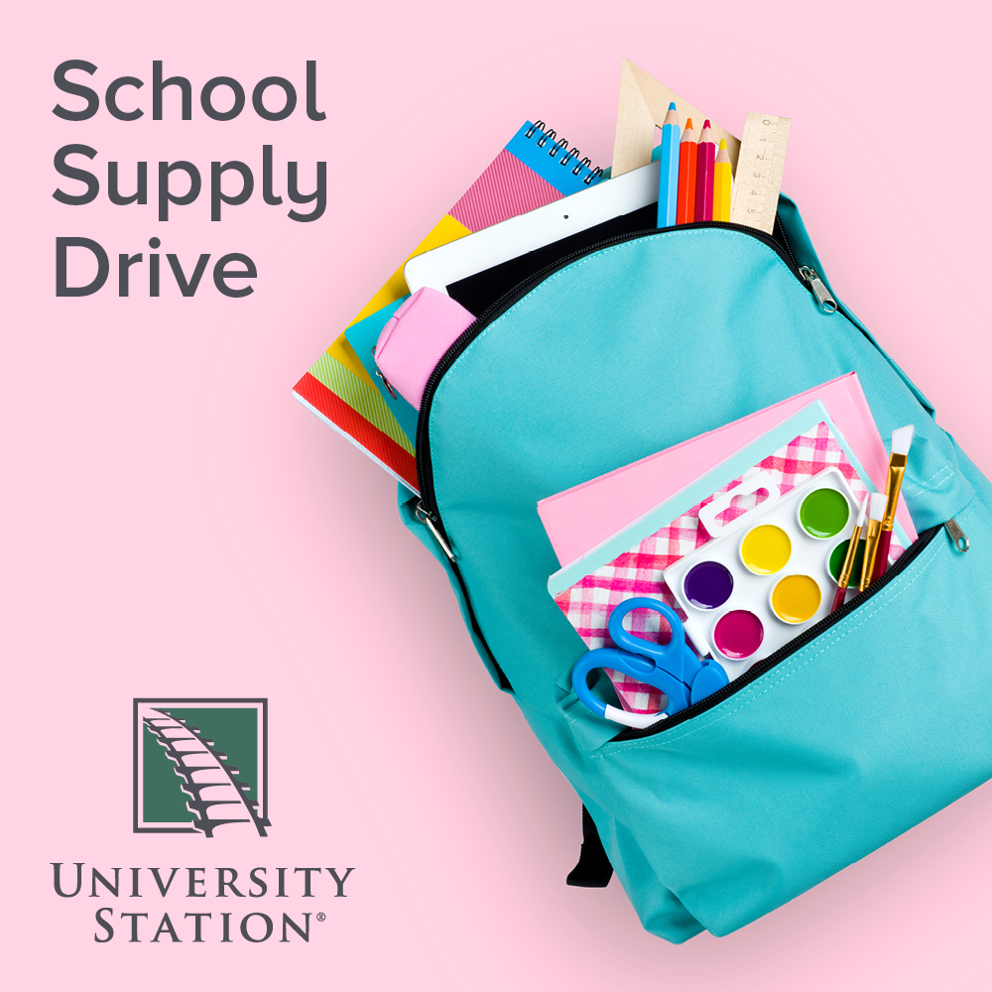

University Station Hosts School Supply Drive for
School on Wheels of Massachusetts

Donations accepted through August 28, 2022

WESTWOOD, MA (August 2022) – University Station in Westwood is hosting a School Supply Drive for School on Wheels of Massachusetts through August 28, 2022. Donations can be dropped off at the marked donation bin located in Five Below.

Suggested donations include new, unused backpacks, pencils & pencil sharpeners, pencil pouches, erasers, glue sticks, highlighters, plastic rulers, washable markers, composition notebooks and more. These donations will directly impact the work of School on Wheels of Massachusetts, whose mission is to support the academic, social, and emotional growth of students impacted by homelessness. Virtual donations to purchase school supplies can be made at SOWMA.BluSchoolSupplies.com.

"There are 24,000 children who are experiencing homelessness in our state and the average age of a homeless person is 8 years old. We currently have over 7,000 backpack requests for students who are experiencing homelessness and poverty. Our backpack program makes a difference to each one of these children. Going into school with a grade level prepared backpack full of needed school supplies helps set a positive tone for these children when they enter the classroom and allows them to start the year on the same playing field as everyone else," explains Barbara Fox, Community Outreach Director for School on Wheels.

“University Station is pleased to continue our partnership with School on Wheels to help children experiencing homelessness to receive the supplies they need to start the school year,” says Rebekah Macchia, Marketing Director of University Station. For more information, visit ShopUniversityStation.com.

About School on Wheels of Massachusetts
School on Wheels of Massachusetts (SOWMA) was founded in 2004 to bring one-on-one academic support to children struggling to stay on track and in school while experiencing homelessness. Since the start of the 2020/2021 academic year, SOWMA has distributed more than 6,000 new customized, grade-level backpacks to children and at-risk youth living in 38 Massachusetts communities. Trained volunteers provide one-on-one tutoring to 280 students at 18 program site locations from Boston to the South Coast. The Bridge Mentoring Program provides 57 high school and college-age students with a volunteer mentor, who shepherds students through high school and onto post-secondary plans, including college, vocational training, and jobs.
For more information, visit SOWMA.Org.

University Station
University Station is a vibrant, mixed-used development in Westwood, Massachusetts combining unique retail, restaurant, residential and office uses. Located on University Avenue at Exit 13 on Route 128/I-95, University Station is adjacent to the Route 128 MBTA Commuter Rail/Amtrak Station. Anchored by Target, Wegmans and Nordstrom Rack, University Station features an exciting mix of restaurants and stores including Del Frisco’s Grille, Anthony’s Coal Fired Pizza, Not Your Average Joe’s, Casa Loca Mexican Cantina, Smashburger, Homesense, Michaels, Marshalls/HomeGoods, PetSmart, Ulta Beauty, and Five Below. Courtyard by Marriott®, Life Time Athletic, Brigham & Women’s Health Care Center, Gables Residential (featuring 350 luxury apartments) and Bridges by Epoch (a memory care facility) are also at University Station. For more information, visit ShopUniversityStation.com.

# # #

