Contact:
Christie Kozak | Leary PR | christie@learypr.com | 978-502-5747

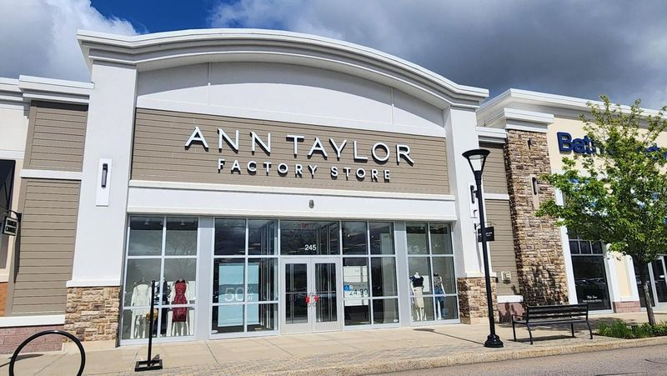

Ann Taylor Factory Now Open at University Station

WESTWOOD, MA (May 2024) - University Station in Westwood (ShopUniversityStation.com)
has announced the opening of Ann Taylor Factory. The store features sleek, sophisticated women's clothing for any season or style. Ann Taylor Factory offers unique, high-quality designs at incredible value including suits, dresses, tops, pants, accessories and so much more. Ann Taylor Factory believes every woman deserves a life of possibility, and that life deserves a wardrobe to match.

“Ann Taylor Factory is an exciting addition to University Station’s retail mix. This iconic brand provides shoppers with timeless styles at incredible prices,” says Rebekah Macchia, Director of Marketing for University Station.

About Ann Taylor
Ann Taylor is an iconic American sportswear brand rooted in a heritage of workwear, iconic silhouettes, signature color, print and pattern. Blending the best of sophisticated, relevant design with notable quality and fit, Ann Taylor lives up to the expectations of today’s accomplished woman through inspirational style for wherever she is headed, a personalized experience, and a belief that empowered women empower women. Founded in 1954 in New Haven, CT, today Ann Taylor has nearly 200 stores and outlets across the US and offers online shopping at AnnTaylor.com. Ann Taylor is part of KnitWell Group, a multi-brand retail operating company comprised of the iconic American apparel brands Chico’s, Haven Well Within, Lane Bryant, LOFT, Soma, Talbots and White House Black Market. With sales of $6 billion on an annual basis, KnitWell Group is one of the largest specialty apparel companies in the United States.

University Station
University Station is a vibrant, mixed-used development in Westwood, Massachusetts combining unique retail, restaurant, residential and office uses. Located on University Avenue at Exit 13 on Route 128/I-95, University Station is adjacent to the Route 128 MBTA Commuter Rail/Amtrak Station. Anchored by Target, Wegmans and Nordstrom Rack, University Station features an exciting mix of restaurants and stores including Del Frisco’s Grille, Anthony’s Coal Fired Pizza, Not Your Average Joe’s, Smashburger, Homesense, Michaels, Marshalls/HomeGoods, PetSmart, Ulta Beauty, Five Below, J.Crew Factory, Bath & Body Works, and Ann
Taylor Factory. Courtyard by Marriott®, Life Time Athletic, Brigham & Women’s Health Care Center, Gables Residential (featuring 350 luxury apartments) and Bridges by Epoch (a memory care facility) are also at University Station. For more information, visit ShopUniversityStation.com.

# # #

