Contact:
Christie Kozak | Leary PR | christie@learypr.com | 978-502-5747
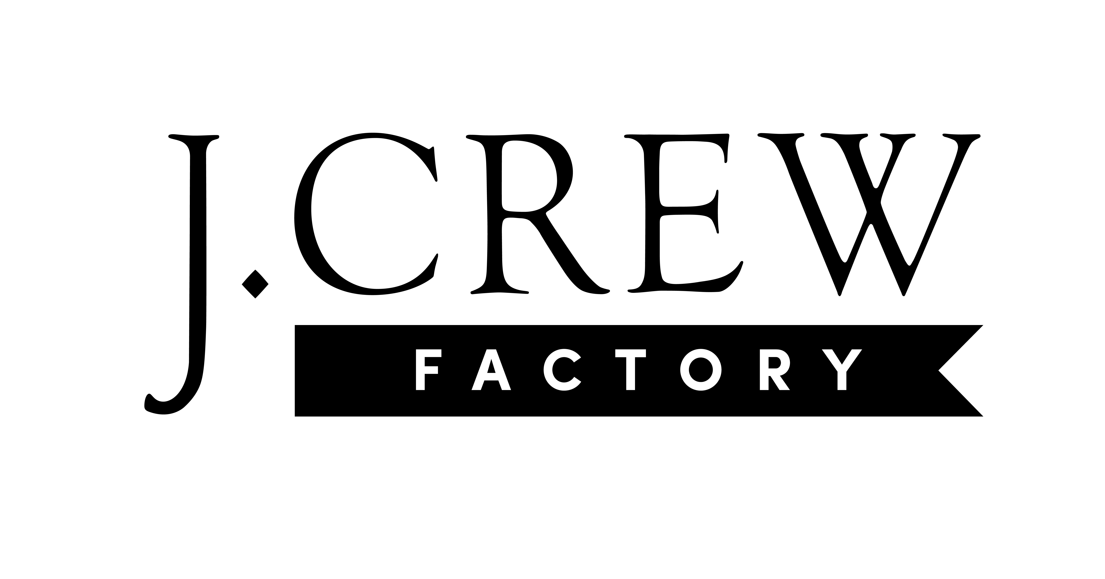
J.Crew Factory to Open at University Station

WESTWOOD, MASSACHUSETTS (February 2023) – University Station (ShopUniversityStation.com) has announced the spring 2023 opening of J.Crew Factory at the center. J.Crew Factory offers fun, classic, and colorful styles for women, men, and kids, and stays committed to dressing every family for any occasion—at a great value. The retailer offers new arrivals monthly, plus exclusive in-store-only offers and events.

J.Crew Factory shoppers are offered various store services, including the option to buy online and pick up in store, book private shopping appointments and benefit charitable causes while they shop. Discounts are offered for teachers, college students, health-care workers, first responders and military personnel.

“We are excited to welcome J.Crew Factory to University Station. J.Crew Factory is an exciting addition to the center’s fashion offerings and is well known for its classic styles for the entire family,” says Rebekah Macchia, Marketing Director for University Station.

About J.Crew Group
J.Crew Group is an internationally recognized omnichannel retailer of women’s, men’s and children’s apparel, shoes and accessories. As of December 1, 2022, the company operates 127 J.Crew retail stores, 155 Madewell stores and 168 J.Crew Factory stores in nearly every state in the United States, and also maintains J.Crew, Madewell and J.Crew Factory websites. For more information, visit JCrew.com, Madewell.com and JCrewFactory.com.

University Station
University Station is a vibrant, mixed-used development in Westwood, Massachusetts combining unique retail, restaurant, residential and office uses. Located on University Avenue at Exit 13 on Route 128/I-95, University Station is adjacent to the Route 128 MBTA Commuter Rail/Amtrak Station. Anchored by Target, Wegmans and Nordstrom Rack, University Station features an exciting mix of restaurants and stores including Del Frisco’s Grille, Anthony’s Coal Fired Pizza, Not Your Average Joe’s, Casa Loca Mexican Cantina, Smashburger, Homesense, Michaels, Marshalls/HomeGoods, PetSmart, Ulta Beauty, Five Below, and J.Crew Factory opening soon. Courtyard by Marriott®, Life Time Athletic, Brigham & Women’s Health Care Center, Gables Residential (featuring 350 luxury apartments) and Bridges by Epoch (a memory care facility) are also at University Station. For more information, visit ShopUniversityStation.com.

# # #

